NWT Project Report

Robert Lothian

HND  Comp Sci

**INTRODUCTION**

The aim of this project is to design and implement a networked system to enable NWT to manage the training centre as well as provide 3 training suites for the trainees to use. I will methodically be working through 4 distinct stages breaking each into tasks through a work breakdown structure to ensure the project is completed quickly and on budget. These stages are initiation and analysis, design, implementation and evaluation.

**IDENTIFYING REQUIREMENTS**

To begin I worked through the brief to identify all the requirements needed in order to satisfy the clients brief. I identified how many resources will be needed, for example I know the training suites are to be equipped for 10 students and one lecturer, there is also management and administration staff who will need equipment, this allowed me to decide on the number of desks, chairs, PC’s and monitors that will need to be ordered and installed. From this I can begin to see how many people I will need to employ in order to complete the project. It also allowed me to begin thinking of a priority of task, for example PC’s will need a desk to be set up on but will not need chairs, this means that whilst someone installs the PC’s another person can be constructing the chairs.

To clarify these needs I created a work breakdown structure in order to list all the job that need to be completed in order to satisfy the clients brief, to supplement this I created a resource document that shows the job titles and hourly rate of people we need to employ.

**GANTT CHART**

With the information from the WBS and Resource list I created a GANTT chart. Within this chart I divided up the tasks into their relevant stage (from the 4 stages). I added milestones upon completion of each stage and began adding dependencies to the tasks in order to come up with a time frame for each task and the entire project. Adding in workers as a resource also allowed me to plan how long a employee would need to be brought in for and if there is any potential to adding an existing member of staff to a task in order to shorten completion time.

**ADDITIONAL TASK AND RESOURCES**

I added a monthly meeting task into the project that recurs every 5th of the month and lasts 2 hours. This meeting is to discuss the overall progress of the project and allow for team members to flag any challenges that they may be facing completing their tasks. It also allows the team to take stock of the progress of the entire project. I also added in a resource for the rental of a project office for £5000. This was added at the start of the project under the initialisation and planning phase.

**Work Breakdown Structure**

**Project Initialisation and Analysis**

Identify client requirement – 5hrs

Feasibility Study – 2hrs

Project Charter – 8hrs

Assemble Team – 16hrs

Project Management Office – 6hrs

Review – 3hrs

**Design Phase**

Identify network requirements – 3 hrs

Source materials – 4hrs

Design network topography – 4hrs

Produce network diagram – 3hrs

Produce floorplan – 5hrs

**Implementation stage**

Connect internet – 14 days

Build tables – 78 hrs

Build Chairs – 19.5 days

Install PC's – 39 hrs

Install Cabling – 6 hrs

Install printer – 1 hr

Configure Server – 3 hrs

**Evaluation stage**

Test connections – 16 hrs

Overload test – 16 hrs

Internet test – 16 hrs

Create documentation – 8hrs

Training – 6 hrs

Handover to client – 2 hrs

**Resource Sheet**

Project Manager – £80ph

Designer - £40ph

Network Administrator - £30ph

Joiner - £12ph

IT installer £25ph

Figure Gantt Chart Project1

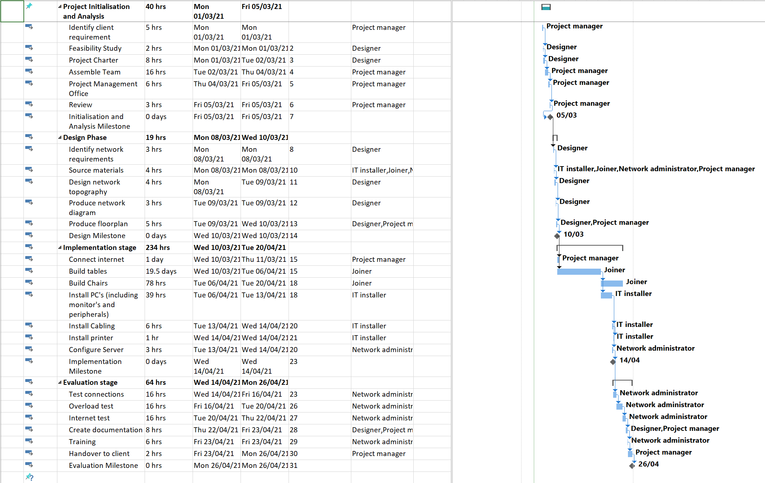

Figure Project1- Meeting Inc

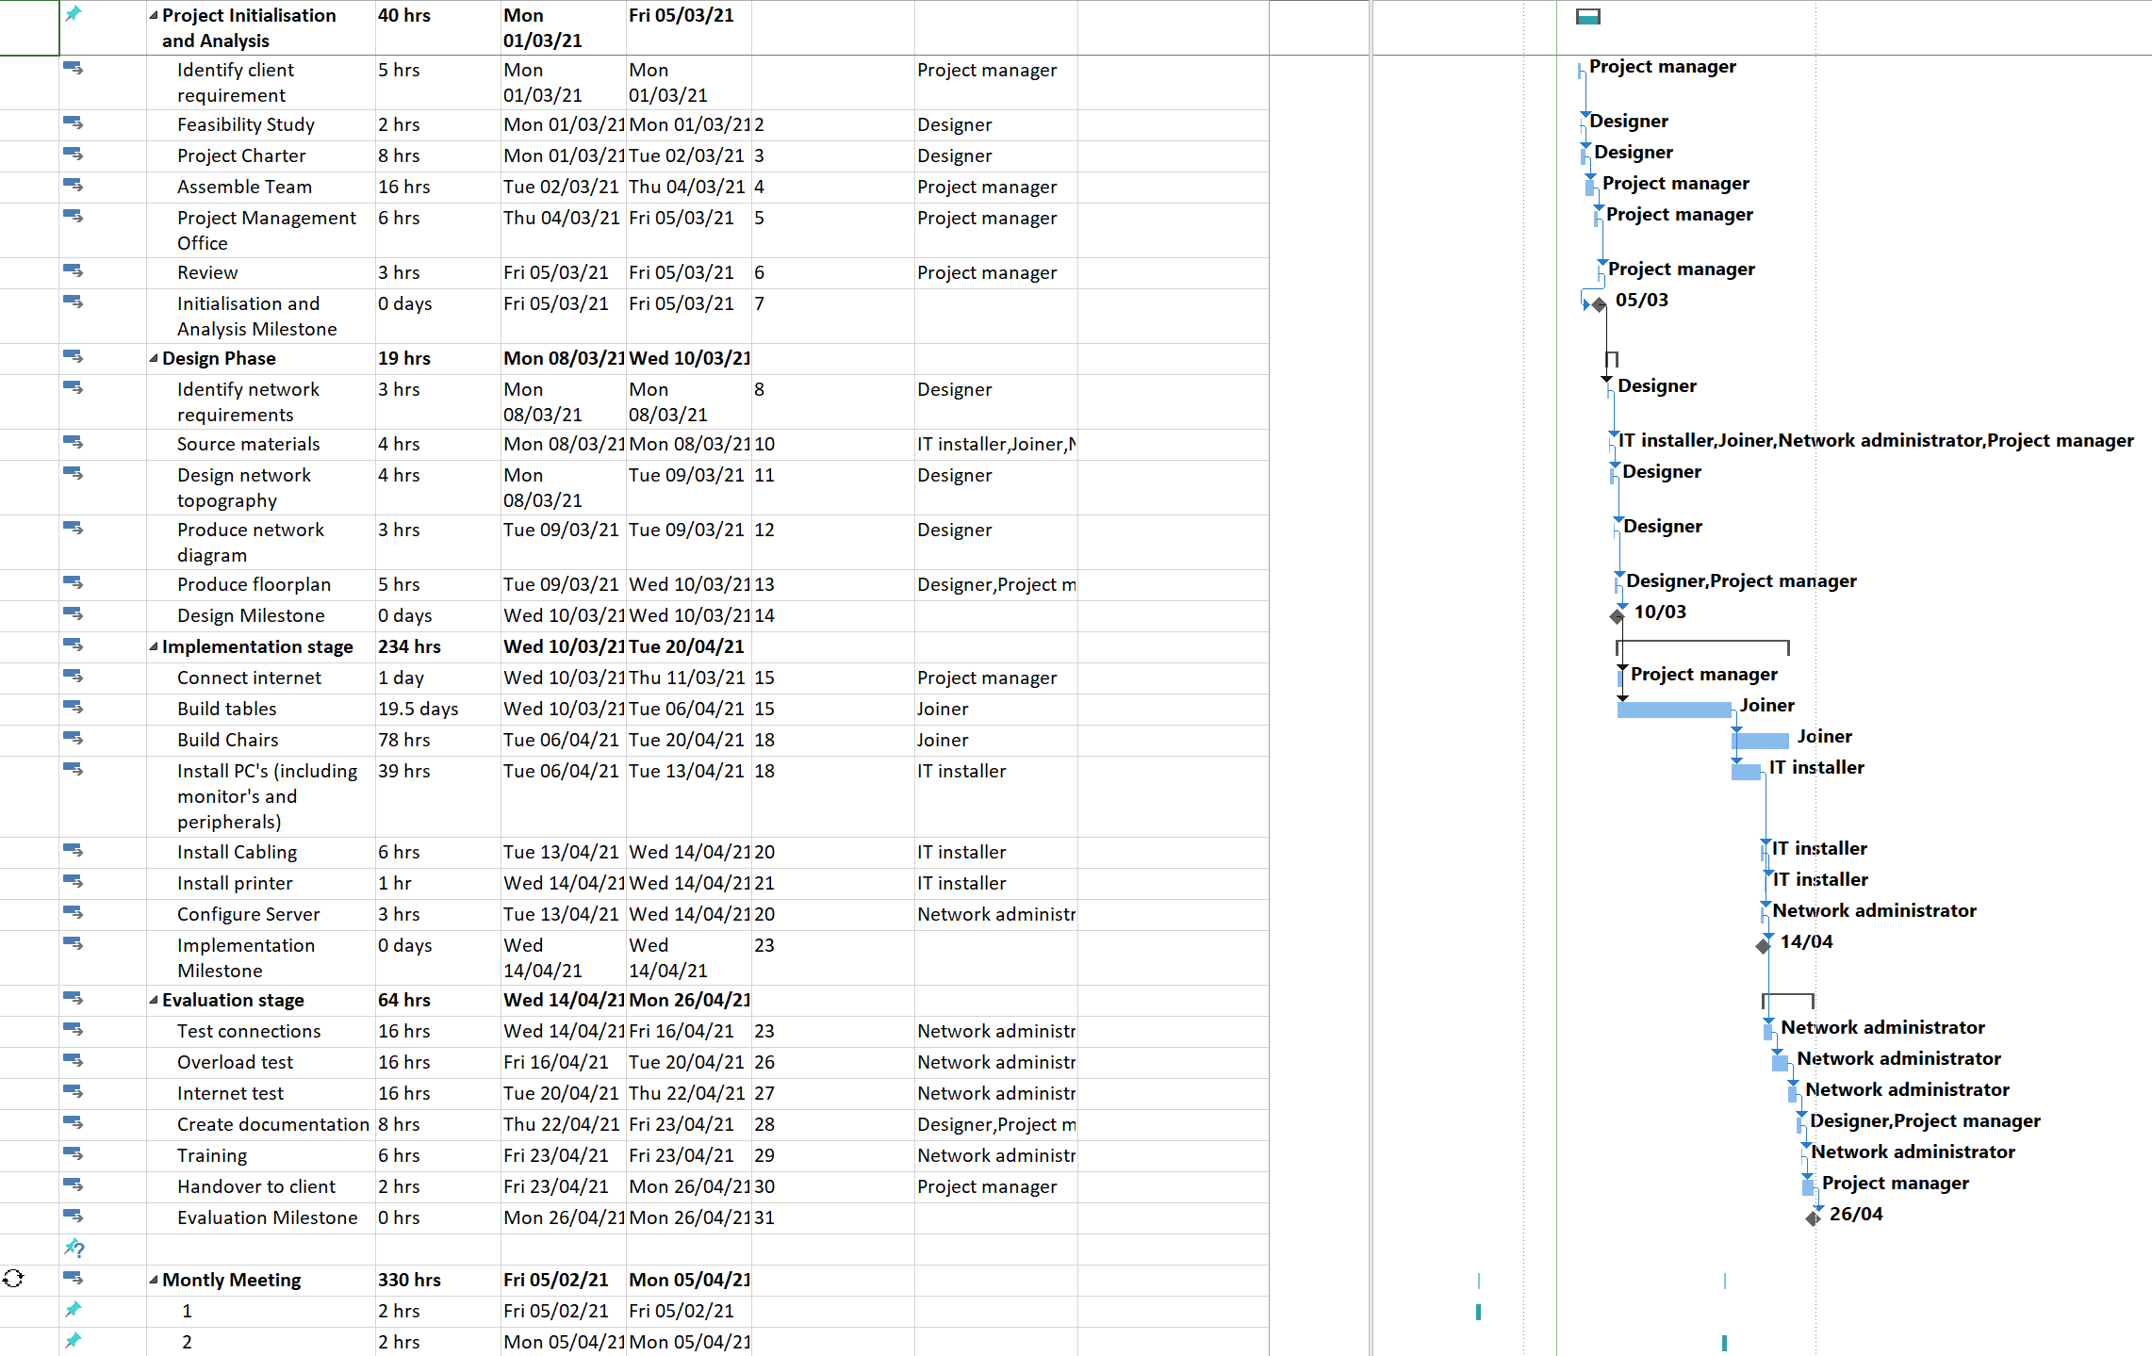

Figure Project1 - Fixed Cost

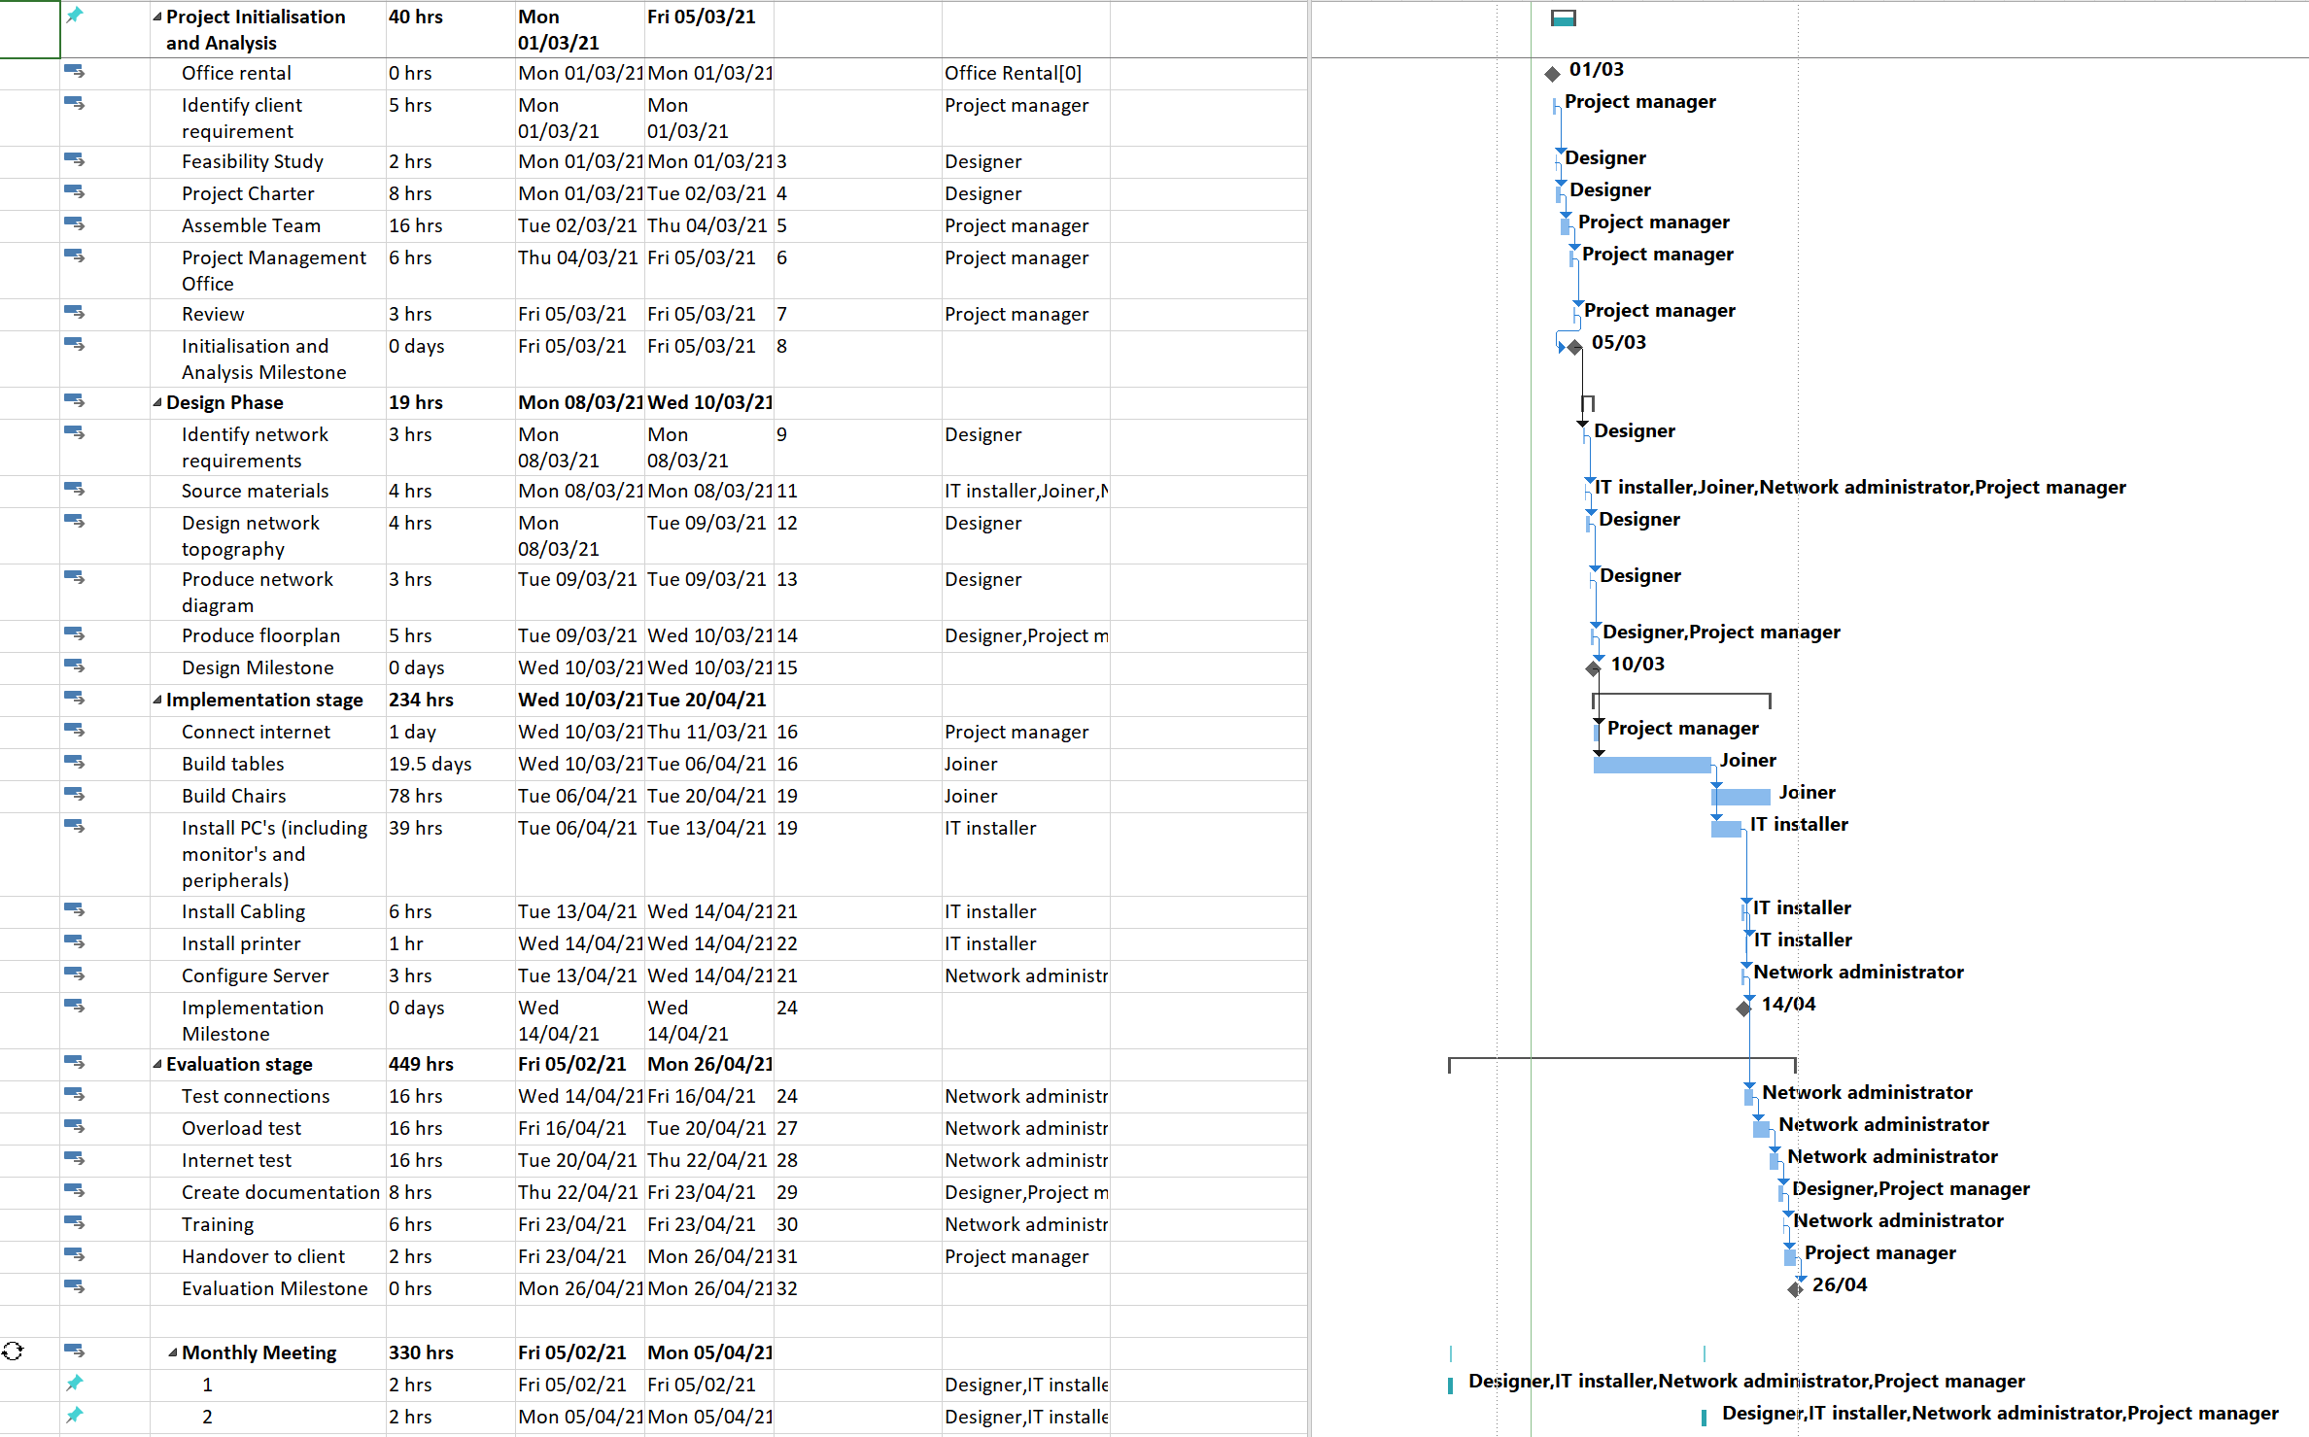

Figure Project1 - Critical Path

